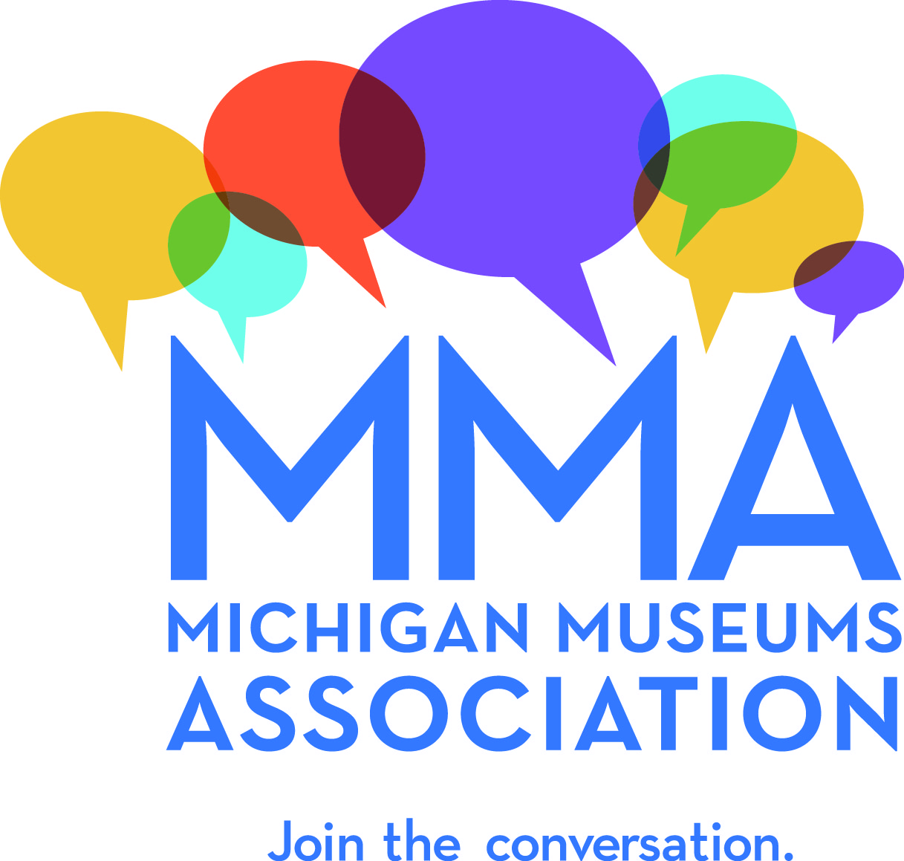
Contact: Lisa Craig Brisson
Michigan Museums Association
michiganmuseums.org
lcbrisson@michiganmuseums.org
Phone 313 334-7643
PO Box 5246
Cheboygan, MI 49721
FOR IMMEDIATE RELEASE
November 10, 2018
Michigan Museums Association Announces Annual Awards Recipients
Dearborn, MI: Michigan museum professionals, volunteers, and supporters recently gathered in Dearborn, MI for the 2018 Annual Michigan Museums Association (MMA) Conference, as well as the MMA Awards. The awards, presented annually by the association, acknowledge excellence in several areas. Four individuals or organizations in the Michigan museum community received awards. The recipients of this year’s awards are:

- MMA Volunteer of the Year – Julie Cook
- President’s Award – John Bracey
- Peninsula’s Prize – Daniel Truckey
- Outreach Award – Birmingam Museum

“It is such an honor to be able to recognize some of the good work and dedicated service in Michigan’s museums. Michigan’s museums provide jobs and support communities. They educate children and engage families and groups. They preserve and share priceless works of art and historic artifacts, and promote scientific exploration and a better understanding of our shared Michigan culture. The individuals honored by us this year represent the thousands of people in our state who are passionate about their work in museums, and are well deserved.”- Lisa Craig Brisson, Executive Director, MMA

MMA Volunteer
The Volunteer of the Year award is given to an individual who has demonstrated exceptional innovation, dedication, and/or commitment to MMA within the past year. For 2018, Julie Cook, The Historic Ford Estates was selected by MMA Executive Director Lisa Craig Brisson in recognition for her outstanding commitment and service to MMA. Cook has been volunteering for MMA since 2015. For the past two conferences, Cook has led the conference Events team, which coordinates the conference evening events as well as afternoon tours of local museums. She developed new processes and initiatives for both of those conference activities, helping to provide a more robust and inclusive conference. This year, Cook was also part of the Houghton County Historical Society Flood Recover Project, a seven-week effort in Lake Linden to help stabilize collections and archives impacted by flash flooding last summer. Julie spent a week helping to catalog and record artifacts rescued from the historical society’s flooded collections building.
“Julie is a delight to work with,” says MMA Executive Director Lisa Craig Brisson, who presented Cook with the award. “Her leadership and dedication has greatly improved MMA’s capacity to provide an excellent experience for conference participants. She is organized, reliable, and enthusiastic, and brings a high level of professionalism and creativity to all she does.”
President’s Award
The President’s Award is bestowed annually to one individual, company, or organization by the current MMA Board President. The award recognizes exemplary support of MMA, service to the Michigan museums field, a career of distinction or for any other criteria deemed appropriate by the MMA Board President. For 2018, MMA Board President Emily Fijol selected John Bracey, Retired, Michigan Council for Arts and Cultural Affairs (MCACA) in recognition of his commitment and service to the profession.
Bracey is originally from Flint. He began at MCACA in 1998 and has tirelessly worked to support museums from the beginning. His first role in the agency was as a program officer, where he worked with many of the largest museums in the state on the anchors program. He was promoted to Executive Director in 2006 and has continued, valiantly, his advocacy for museums and arts and cultural organizations since then. Shortly after his appointment as Executive Director, the state faced a funding crisis and the budget of the department was eliminated. Bracey led the fight to save the department and secured enough funds to at least keep the federal match from the NEA. Since then, he has grown funding for MCACA back to almost 11 million dollars.

“It is no secret that John loves museums…he is an unwavering advocate for museums, arts, and cultural communities in Michigan and nationally,” said Emily Fijol, MMA Board President. “We are grateful for all of his efforts and will miss him.” Bracey will retire in December 2018.
Peninsulas Prize
The Peninsulas Prize is given to an individual or individuals, a museum or museums, or a collection of partnering organizations that have demonstrated the significance and impact of community engagement over the last year. MMA awarded the 2018 Peninsulas Prizes to Daniel Truckey, Beaumier U.P. Heritage Center at Northern Michigan University.
“Dan has been a quiet leader for the field in the state for the past 16 years, the past 12 years at
the Beaumier U.P. Heritage Center at Northern Michigan University. Under Dan's leadership, the Beaumier U.P. Heritage Center has compiled an astonishing record of community engagement and educational outreach in the Upper Peninsula,” said Nathan Kemler, MMA Board Vice President, who presented the award. Specifically, creating twenty major exhibitions related to the history and culture of the Upper Peninsula, seven of which have toured the Upper Peninsula; presenting an average of twenty-five public programming events each calendar year since 2009, including concerts, symposiums, lectures, workshops, films, food events, bus tours and private tours; two time recipient of grant funds from Arts Midwest to host residencies of traditional folk music groups in Marquette County, programs that impacted nearly 10,000 schoolchildren and hundreds of community members; the Beaumier Center created the Upper Peninsula Heritage Awards in 2009, which has recognized 12 tradition bearers and preservationists in the region. Truckey is a long time member of MMA and served on the board of directors from 2007-2011.

Outreach Award
The Outreach Award, a new award, is given to an organization that has developed a new or revamped museum educational program or project which is unique, innovative, and community-driven. MMA honored the Birmingham Museum for its exhibit, The People of Birmingham: 200 Years of Stories. The exhibit took a unique and engaging approach to sharing Birmingham’s history through personal stories submitted by the public as part of the celebration of the city’s bicentennial.
Among the goals of the exhibit was to connect with the community and reflect the people who make Birmingham special, and to reach new audiences in the process, objectives that are integral to the museum’s mission and strategic plan. Participants were invited to share photos and loan artifacts, and the museum hoped to gain new information for its archives that would help future researchers. What the museum did not anticipate was the spike in memberships, social media activity, object donations, and the surfacing of amazing photos and artifacts for the museum’s collection.
“It [the exhibit] surpassed our expectations by a mile,” said Birmingham Museum Director, Leslie Pielack. “We have had the best of all worlds-we gained so much for the museum while giving the community a chance to share their collective history and document it for future generations.” The museum will be creating an online exhibit and producing a printed booklet of the contributed stories after the exhibit closes in January of 2019. Malcolm Cottle, Chair of the Awards Committee for the MMA Annual Conference, presented the award.

The Michigan Museums Association is a catalyst for advancing Michigan’s museum community through shared learning, advocacy and collaboration. MMA has been supporting the work of Michigan museums for over 60 years. Our members include the institutions, professionals and volunteers of the Michigan museum community who believe that strong museums help us better understand ourselves and our world. Every type of museum is represented and welcomed, including art, history, science, military and maritime, and youth museums, as well as aquariums, zoos, botanical gardens, arboretums, historic sites, and science and technology centers.

Photos of the awardees are available at http://www.michiganmuseums.org/2018-Awards-Photos/

